**Information System Management Lab**

**BCOM 307**

**Assignment #9**

***Submitted by:***

**Name:** YASH JAIN

**Enrollment No:** 03914788818

**Semester:** B.Com(H) 5th Semester

**Class:** B.COM(H)

**Section:** B.Com 5A

**Date of Submission:** 01/10/2021

***Submitted to:***

**Praveen Kumar Singh**

**Assistant Professor, MAIMS**



**Department of Commerce**

**Maharaja Agrasen Institute of Management Studies**

**Affiliated to Guru Gobind Singh Indraprastha University, Delhi**

**Sector -22, Rohini, Delhi -110086, India; www.maims.ac.in**

Maharaja Agrasen Institute of Management Studies

Affiliated to GGS IP University; Recognized u/s 2(f) of UGC Recognized by Bar Council ofIndia; ISO 9001: 2015

Certified Institution Sector 22, Rohini, Delhi -110086, India; [www.maims.ac.in](http://www.maims.ac.in/)

Department of Commerce

Academic Year: 2020-21

Semester: Vth

# Assignment No.9

# Unit No:

**Course/Subject Code:** BCOM 307 **Subject Title: Information System Management Lab**

# Issue Date: Last Date of Submission:

**Instructions for Students:**

# All Questions are Compulsory.

1. The student should attach proper cover page for each assignment clearly mentioning the Assignment No.
2. Each assignment should be prepared by the student individually with proper explaination and screenshots.
3. A4 size ruled sheets should be used for the assignment.
4. Assignment pages should be serially numbered at the bottom of page.

***During online education mode, upload scanned copy of the complete assignment including cover page latest by due date.***

|  |  |  |
| --- | --- | --- |
| **Question No.** | **Question** | **CO No.** |
| 1 | Add a new column 'Salary' to the client_master table. | **CO1** |
| 2 | Update salary values for all the clients with different values. |
| 3 | Update salary to 10,000 for client ID 101. |
| 4 | Add a column 'mobile number' with datatype int(10). |
| 5 | Display all the clients where salary > 3000 and baldue < 15000. |

**ASSIGNMENT 9 - ALTER COMMAND**

**Task 1 : Add a new column 'Salary' to the client_master table.**

The following task is completed using the **‘alter table’** command, along with the **‘add’** keyword. The ‘Alter’ command allows changing the existing structure of a table. With ALTER Command, you can add or delete columns, change the data type of existing columns, or if you want to rename the columns or the table itself. The syntax for this is:

Alter table <tablename> ADD column_name datatype constraint(if applicable);

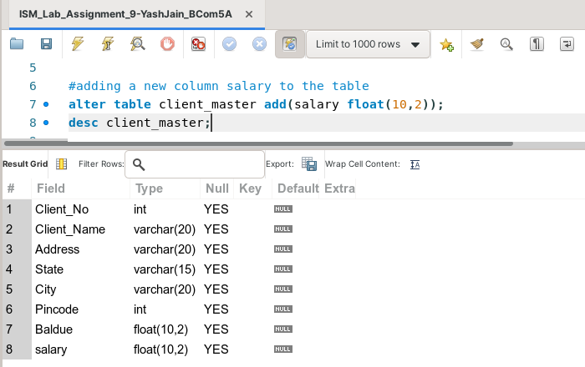

**Task 2: Update salary values for all the clients with different values.**

The following task is completed using the **‘update’** command, along with the **‘SET’** keyword, and the **‘where’** clause.

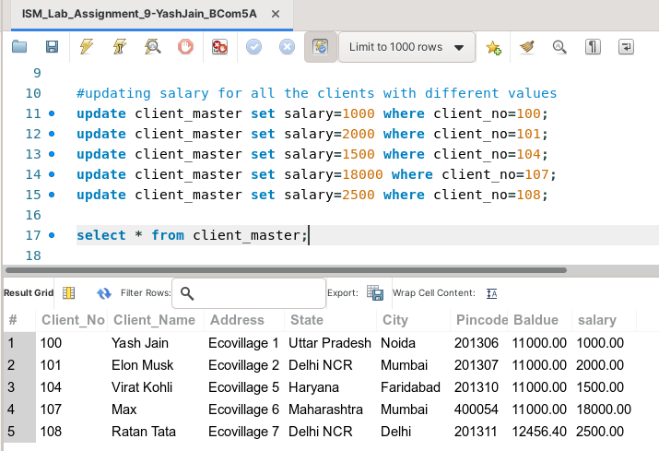

**Task 3: Update salary to 10,000 for client ID 101.**

This task can be completed using the **‘update’** command along with the **‘SET’** keyword, and the **‘where’** clause.

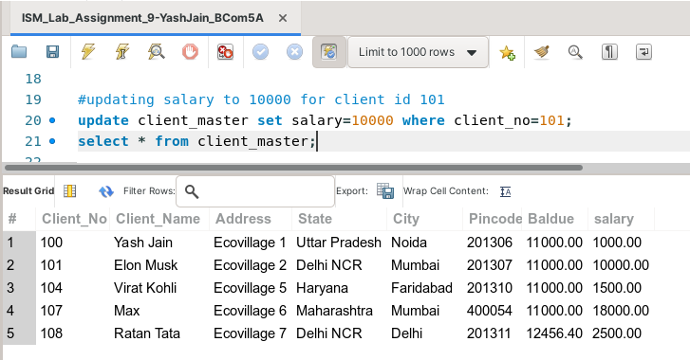

**Task 4: Add a column 'mobile number' with datatype int(10).**

The following task is completed using the **‘alter table’** command, along with the **‘add’** keyword.

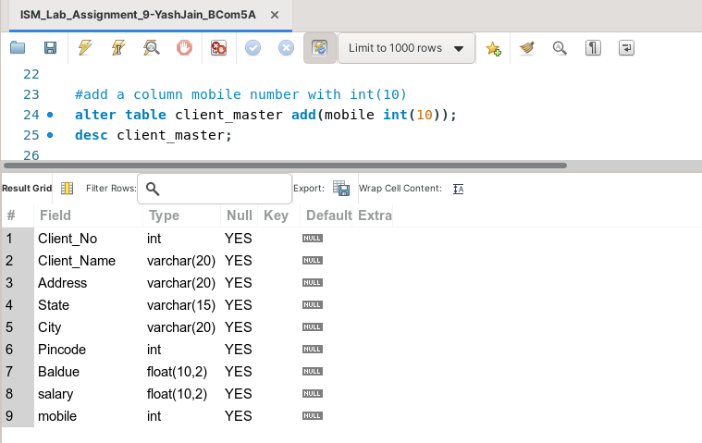

**Task 5: Display all the clients where salary > 3000 and baldue < 15000.**

This task can be completed using the **‘select’** command, with the **‘where’** clause and the **‘and’** operator.

